CPT-202 Shawn Conboy ASSIGNMENT – 4 SQL
- USE KimTay Pet Supplies DATABASE
- Each question is worth 5 points.
- Answer each of the following questions after reading/reviewing Chapter 4 of your textbook.
- For questions that require SQL Code, submit both your SQL Code and the Output/Results.
- Submit your answers in a Word document via the Assignments link in D2L.

- List the item ID, description, and price for all items.
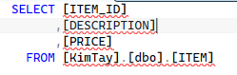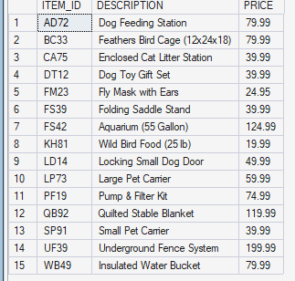
- List all rows and columns for the complete INVOICES table.
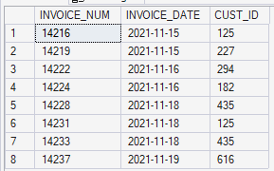

- List the first and last names of customers with credit limits of $1,000 or more.
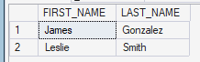
- List the order number for each order placed by customer number 125 on 11/15/2021. (Hint: If you need help, use the discussion of the DATE data type in Figure 3-16 in Module 3.)
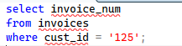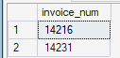
- List the number and name of each customer represented by sales rep 10 or sales rep 15.
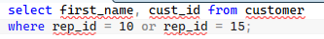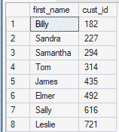
- List the item ID and description of each item that is not in category HOR.
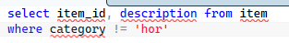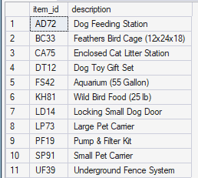
- List the item ID, description, and number of units on hand for each item that has between 10 and 30 units on hand, including both 10 and 30. Provide two alternate SQL statements to produce the same results.
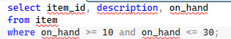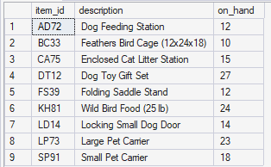
- List the item ID, description, and on-hand value (units on hand * unit price) of each item in category CAT. (On-hand value is technically units on hand * cost, but there is no COST column in the ITEM table.) Assign the name ON_HAND_VALUE to the computed column.
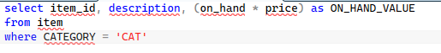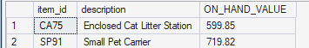
- List the item ID, description, and on-hand value for each item where on-hand value is at least $1,500. Assign the name ON_HAND_VALUE to the computed column.
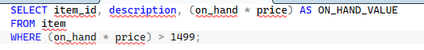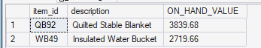

- Use the IN operator to list the item ID and description of each item in category FSH or BRD.
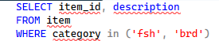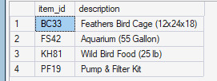
- Find the ID, first name, and last name of each customer whose first name begins with the letter “S.”
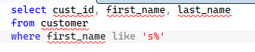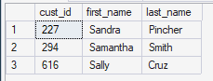
- List all details about all items. Order the output by description.
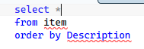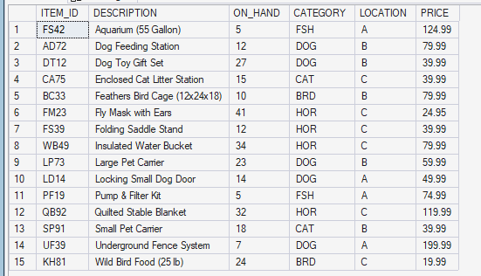

- List all details about all items. Order the output by item ID within location. (That is, order the output by location and then by item ID.)
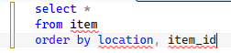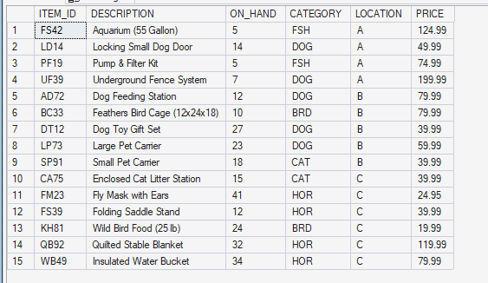
- How many customers have balances that are more than their credit limits?
1
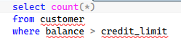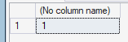
- Find the total of the balances for all customers represented by sales rep 10 with balances that are less than their credit limits.
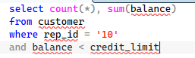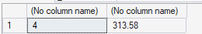

- List the item ID, description, and on-hand value of each item whose number of units on hand is more than the average number of units on hand for all items. (Hint: Use a subquery.) Unsure.
- What is the price of the least expensive item in the database?
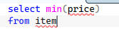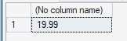
- What is the item ID, description, and price of the least expensive item in the database? (Hint: Use a subquery.)
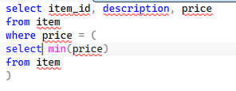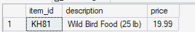
- List the sum of the balances of all customers for each sales rep. Order and group the results by sales rep ID.
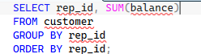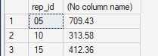
- List the sum of the balances of all customers for each sales rep but restrict the output to those sales reps for which the sum is more than $150. Order the results by sales rep ID.
